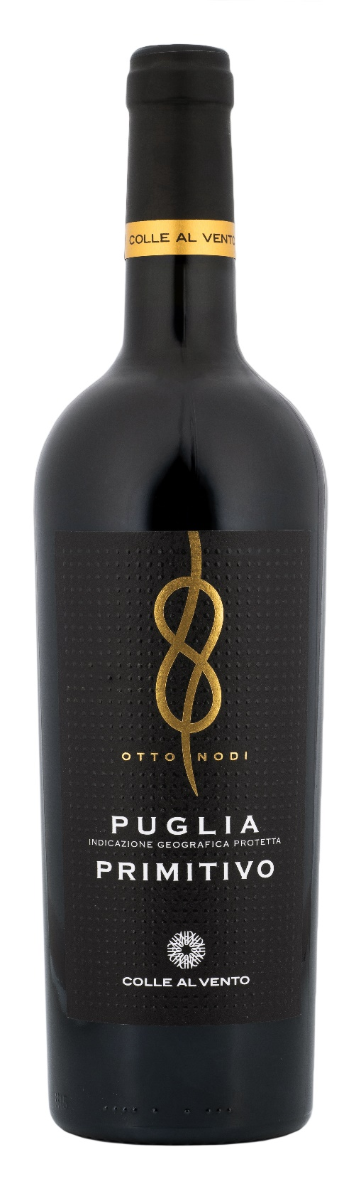
PRIMITIVO PUGLIA IGP OTTO NODI

Grape: Primitivo 100%
Alc. Vol.%: 13,5
Vintage: 2025
Residual sugar g/l: 15,0
Total acidity g/l: 5,7
Region: Apulia
Production zone: Vineyards in Northern Apulia
Capacity: 750ml

CHARACTERISTICS

Vinification: Traditional short maceration at a controlled temperature. To better extract colour and tannins, it is pumped over several times
Aging: In steel tanks for about 6 months
Yield per ha: 12000kg
Colour: Intense bright red with purple reflections
Bouquet: Fruity, intense
Flavour: Soft, rounded e velvety

SERVING SUGGESTIONS

Perfect to pasta dishes, pizza and grilled meat.
Serving temperature 14-16 °C
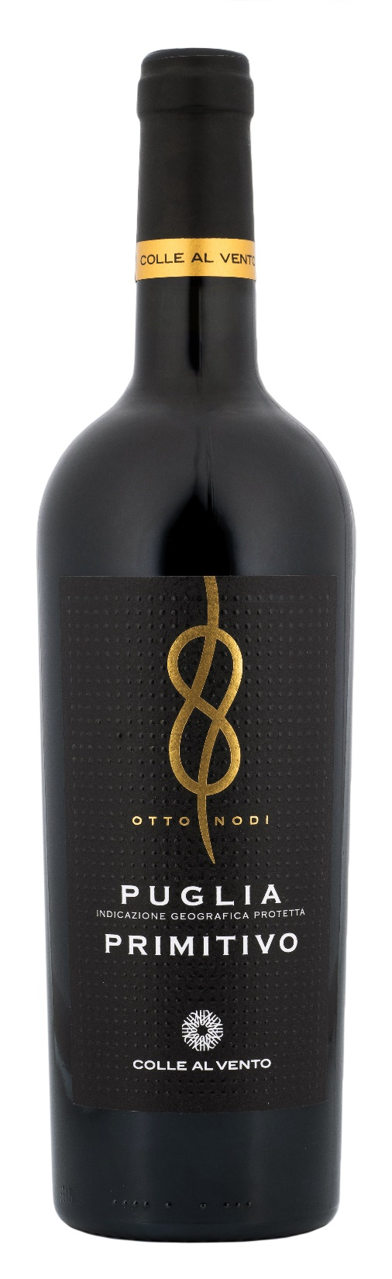
TECHNICAL INFORMATION / PALLETIZING

Size 750ml:
Article Nr. V03015A
GTIN-13 bottle 8017868001423
GTIN-13 carton 8017868001430
Closure Cork
Bottles / carton 6 bottles
Pallet size 80x120cm
Cartons/layer 21
Cartons/pallet 105
Kg/carton 7,9
Kg/pallet 845

Contains sulphites
GMO Free
Revisione 01. 14.05.2026

